
Student Night

Wednesday, April 26, 2006

Location:
Vernon Manor
400 Oak Street (intersection with Burnet Ave)
Cincinnati, OH 45219
Tel: (513)281-3300
Time:
Social/Registration 5:30 – 6:00 PM
Speakers 6:00 – 7:30 PM
Dinner 7:30 – 8:30 PM

Registration Fee:
Members $35 ………. At-the-door $45
Non-members $55 ………. At-the-door $60
Students $15
➔ These meetings are subsidized and NO-SHOWS cost the OVSCC money due to our need to commit in advance for prepared meals. Please consider this before registering. Thank you for your consideration.

Dinner Selection:
- Chicken Cordon Bleu (Stuffed with Ham and Swiss Cheese)
- Salmon with an Orange Tamari Glaze
- London Broil (Beef) (with port wine and roasted shallot sauce)
- Vegetable Napoleon (Grilled Vegetables with a Marinara Sauce)
Ohio Valley
Society of Cosmetic Chemists

2006 Officers

Chair:
Eric Abrutyn
513-455-5521
eric.abrutyn@kaobrands.com

Chair-Elect:
Jim Staudigel
513-626-1812
staudigel.ja@pg.com

Treasurer:
David Mosko
513-891-7508
david.mosko@nstarch.com

Secretary:
Julie-Ann Moser
513-241-4555
Julie.moser@onassignment .com

Directors Area II:
Chris Heisig
314-290-4747
chris_heisig@steris.com

Jim Vlasic
952-707-6904
jvlasic@greenwaylab.com
The speakers for Students Night are:

Jennifer Canning
“Use of High Resolution Digital Imaging to Quantify Erythema of the Hands of Health Care Providers”

Hamali Gant
“Hydration Effect on Human Nail Permeability”

Smita Chawla
“On The Efficacy and Safety of a Novel Tyrosinase Inhibition Deoxyarbutin, and it’s Second Generation Derivatives”

Please contact Andrew DiMuzio with your reservation and meal selection by Friday, April 19th at 513-455-7548 or andrew.dimuzio@kaobrands.com.

Directions to Vernon Manor:
Northbound:
From I-71 N, take Exit 2, which is the Reading Rd. exit (left hand lane). Follow Reading Rd. north for six traffic lights. At sixth light, take a left on Oak Street.

Southbound:
From I-75 S, take Hopple St. exit. Follow the signs for University of Cincinnati. Hopple St. will turn into Martin Luther King Dr. Turn right onto Burnet, go two blocks and take a left onto Oak St.

There is free valet parking.

Abstract:

“Use of High Resolution Digital Imaging to Quantify Erythema of the Hands of Health Care Providers” by Jennifer Canning
Erythema is defined as an abnormal redness of the skin due to dilation of capillaries and is often a sign of inflammation or infection. The degree of skin erythema seen in clinical trials is often based upon subjective observations, i.e. Visual Skin Grading (VSG). The drawback of these subjective observations is their low reliability and reproducibility. Therefore, there is a need for the development of objective, quantitative techniques for the evaluation of changes in skin color that is cost effective and simple to use. Numerous objective and quantitative techniques have been studied in previous clinical trials, but these techniques are generally too expensive and/or too complex to handle in a clinical setting.
Digital Image Analysis (DIA) uses three color channels (RGB – red, green, and blue) to collect the reflected light from the skin. High resolution digital images were collected from summer and winter clinical trials that were carried out to examine the effects of hand hygiene products on the condition of the hands of health care providers working in an intensive care unit. Two images were taken of each subject per visit: one of the left hand and one of the right hand. Many different techniques were used to quantify the images using computer analysis, including computing the percentage of red pixels contained in each of the images and calculating the area of redness in each of the image’s histograms. The images were also examined by expert graders using a computer program called VPS for the benefits of additional information with the use of another technique. Differences between VSG and DIA assessments were determined by examining differences, if any, in the left versus the right hand, the summer versus the winter trial and changes during the work cycle of the subjects and during the allotted time off of the subjects.

“Hydration Effect on Human Nail Permeability” Hamali Gant
The mechanical and transport properties of several keratinized membranes (horn, wool, hair and human stratum corneum) have been shown to relate to water content. While this information is fundamental, literature review shows a paucity of data with respect to human nails. An understanding of hydration effects on nail permeability may be useful clinically and cosmetically in topical treatment of nail disorders. The purpose of this project is to clearly define the effects of hydration on human nail permeability. In the first part we have determined the equilibrium water sorption and desorption isotherms for human nail and analyzed the data according to theoretical sorption models – D’Arcy-Watt, Frenkel-Halsey-Hill (FHH) and Guggenheim-Anderson-de Boer (GAB). Of the several models tested, the D’Arcy-Watt model gave the most useful description of water sorption in nail over a wide range of RH. We have also quantified transport parameters for water and an antifungal ketoconazole in human nail over a complete range of hydration. Results from our studies show that water diffusivity in the nail depends sensitively on water content, similar to other keratinized tissues. The magnitude of the change can be explained by a free volume approach. Results from our antifungal permeation studies show that increased hydration has an enhancing effect on healthy human nail permeability. The effect of hydration on diseased nail permeability needs to be studied in order to apply this finding clinically.

“On The Efficacy and Safety of a Novel Tyrosinase Inhibition Deoxyarbutin, and it’s Second Generation Derivatives” by Smita Chawla
The efficacy and safety of tyrosinase inhibitors used as skin lightening agents currently on the market (i.e. hydroquinone, kojic acid and arbutin) have been undesirable. We have recently developed a novel tyrosinase inhibitor deoxyArbutin (dA) and propose that it, along with second-generation derivatives (i.e. deoxyFuran, thio-dA and fluoro-dA), have the potential to be effective inhibitors of skin melanization. The effect of these compounds on viability of dark and light cultured human melanocytes was assessed to determine noncytotoxic concentration. Melanin content, protein content and tyrosinase activity were analyzed after treating melanocytes with these compounds for 5 days. dA and its second-generation derivatives, at their respective noncytotoxic concentration inhibited tyrosinase activity, subsequently down-regulating melanin synthesis.
Concentrations of dA and its derivatives that did compromise viability of melanocytes resulted in an inhibition of cell proliferation (i.e., cytostatic) as oppose to the development of apoptosis (i.e., cytotoxic) that was induced by hydroquinone. In order to determine whether tyrosinase and/or tyrosinase related protein-1 (Tyrp1) mediate this cytostatic effect of these compounds, dark and light normal human melanocytes, and melanocytes derived from occulocutaneous albinism 1 (tyrosinase mutant) and occulocutaneous albinism 3 (Tyrp-1 mutant) patients were treated with each test compound for 5 days. Results demonstrate that the cytostatic effect of these compounds is mediated by both tyrosinase and Tyrp1 suggesting that dA affects both melanogenic enzymes.
The cytostatic effects of dA were not ameliorated by exogenous supply of antioxidants. In contrast, endogenous catalase was upregulated in melanocytes exposed to dA. A moderate amount of reactive Oxygen Species (ROS) was generated upon treatment with dA, in contrast to the dramatic amount of ROS induced by hydroquinone. These results demonstrate that dA, and its second generation derivatives, are safe, effective skin lightening agents.

Eric’s Insights

I want to thank everyone for coming to the February meeting. Once again we all found the atmosphere and food at Maggiano’s one of our most popular meeting venues. Over thirty people had the opportunity to listen to Dean Smith of Colonial Chemicals talk about the evolution of Alkyl Polyglucosides and new emerging applications.

The April meeting is shaping up to be another great Student’s Night. This is a “not to be missed” meeting where you will hear about the research going on in the University of Cincinnati School of Pharmacy. Dr. Randy Wickett and Dr. Jerry Kasting have some of the best future talent incubating in a great program right here in Cincinnati. Let’s come in force to demonstrate our appreciation of the work they are doing.

We are still looking for short technical articles for our newsletter. So far no takers, thus you force me to start the ball rolling; that is egg rolling.

Ever wonder why an egg coagulates? How do you make the perfect boiled egg? Can you really get the yolk centered in a hard boiled egg?

The egg white contains about 10% protein (amino acid folded upon themselves in a shape of a ball) and 90% water. The key proteins are ovalbumin, ovatransferrin, ovamucoid, and ovamucin. The yolk contains lipids and fats and little water; making it less dense than water (~ 50%), or the egg white portion. So if you keep the egg moving while boiling the yolk will be centered when the whites coagulate.

Cooking an egg will partially unravel the egg white proteins (“denatured”) forming a lattice that traps water and fat (“gel”). The egg white proteins denature around 62C producing a gel coagulate with trapped water. Heat faster and higher (boiling water @ 100C) will squeeze out more water and the gel will become rubbery. The yolk needs around 68C to start coagulating so it can remain more liquid at lower temperatures. Thus time verses temperature is a key to the perfect egg. To prove this, I experimented at home with making a fried egg. Instead of heating in a very hot skillet, I used a low temperature and thermometer so as not to exceed 65C. The whites were perfect and a nicely cooked runny yolk. Of course the family grew impatient waiting for the egg to cook.

Adding sugar to the egg will decrease the rate of heat necessary for denaturation and increase the coagulation time. Adding salt will promote coagulation. Punching a pin hole in the shell of the egg will prevent it from cracking while making a hard boiled egg (allows the air to escape and not build up pressure in the shell).

Knowing some simple facts about simple egg, allows us to start to thinking of it in all its complexity; allowing science and chemistry to play a role in how we treat or mistreat it when cooking with any part of the egg.

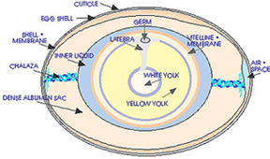  Modified from "USDA Egg Grading Manual" 1969. Agriculture Handbook No. 75. | % Composition Whole Egg  65.5% Water  11.8% Protein  11.8% Protein  11.0% Fat  11.7% Ash

Do not want to read my stuff? Please submit a short article about anything that relates to science and we will be happy to consider it for publication in our next August newsletter (deadline July 1, 2006).

SAVE THE DATES -- Upcoming events:

May 11-12, 2006 | SCC Annual Scientific Seminar; Boston, Mass
May 16-17, 2006 | New York Chapter Supplier’s Day; Raritan, NJ
June 7, 2006 | CEP Free Course on “Scale-Up” by David Yacho; Covington, KY
September 18, 2006 | OVSCC Golf Outing – Twin Oaks Golf & Plantation Club; KY
September 19, 2006 | OVSCC Half Day Mini-Symposium, Location TBD
November 15, 2006 | OVSCC Meeting and Officer Installation, Location TBD
December 7-8, 2006 | SCC Annual Meeting Technology Showcase, NYC, NY

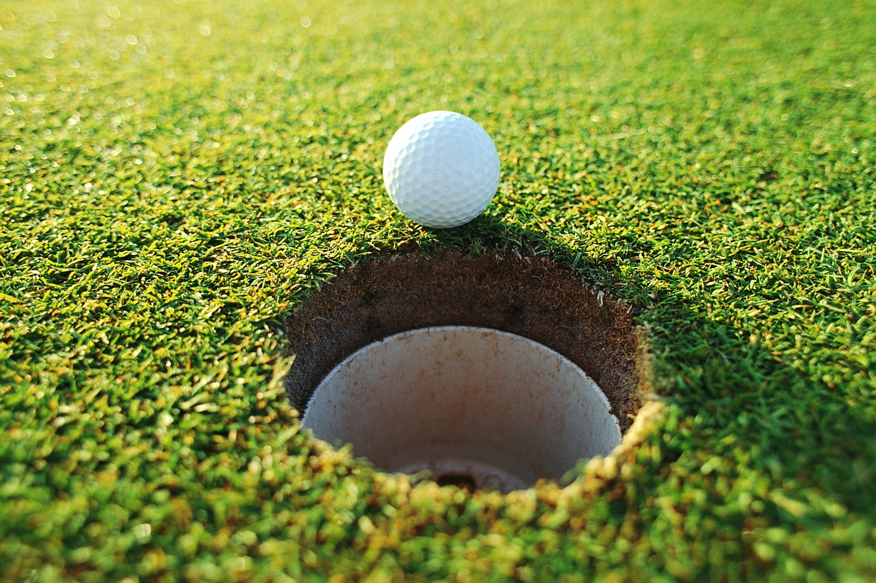

SAVE the DATE!!
8th Annual OVSCC Education Scholarship Golf Outing
@ Twin Oaks Golf & Plantation Club - KY
Date: Monday, September 18, 2006
Time: Shotgun start @ 10:30am
Registration to start at 9am.

Please contact Julie Moser for questions, hole sponsorships, and reservations by August 25th at 513-455-4555 or julie.moser@onassignment.com. Hole Sponsorship $150 + 2 dozen golf balls. Cost to Play $100/per person. Sponsor a hole, register a foursome, and pay by June 1, 2006 to receive a complimentary FREE registration to the September 19th ½ Day Technical Symposium

This includes:
18 holes green fees and cart fees
Lunch ticket (choice of sandwich & chips)
Draft Beer*, Unlimited Sodas, & Bottled Water
Chips & Pretzels after Golf
& The Plantation Club Buffet including
A Bountiful Salad Bar
Chef Carved Glazed Ham
Blackened Salmon
Oven Roasted Turkey Breast
Garlic Mashed Potatoes
Country Green Beans
Dinner Rolls
Dessert Display & Coffee

Please Visit www.golfattwinoaks.com/ for Photos, Maps/Directions, or More information on the course. See you in September!

Free Ohio Valley SCC CEP
“Scale-up”
Are you a member of the Ohio Valley SCC? If so, did you know you are entitled to participate in a FREE SCC continuing education course on June 7th? If you are interested please contact Eric Abrutyn at eric.abrutyn@kaobrands.com or 513-455-5521 for more information.

Get in synchronization with our new venue and your customers

See how Supplier’s Day can expand you company horizons.

Come join the New York Chapter
in welcoming our vendors and
opening Supplier’s Day.

Opening Ceremony At the Raritan Expo Center, in Edison, New Jersey on
Monday, May 15th
At 5:00 pm – 7:00 pm

All are welcome to attend.
Dress: Casual

Cocktails and Hors d’oeuvres will be served.

The Ohio Valley Chapter Newsletter is published in February, April, September and November prior to each chapter meeting. Questions concerning the newsletter should be directed to the Editor. Questions concerning advertising should be directed to the Business Manager.

Editor Business Manager
Susan Littell Paul McOsker
Kao Brands Co. North Cliff Consultants
2535 Spring Grove Ave. 3747 Warsaw
Cincinnati, OH 45214 Cincinnati, OH 45205
513-455-5533 513-251-4930
susan.littell@kaobrands.com pmcosker@northcliff-testing.com

